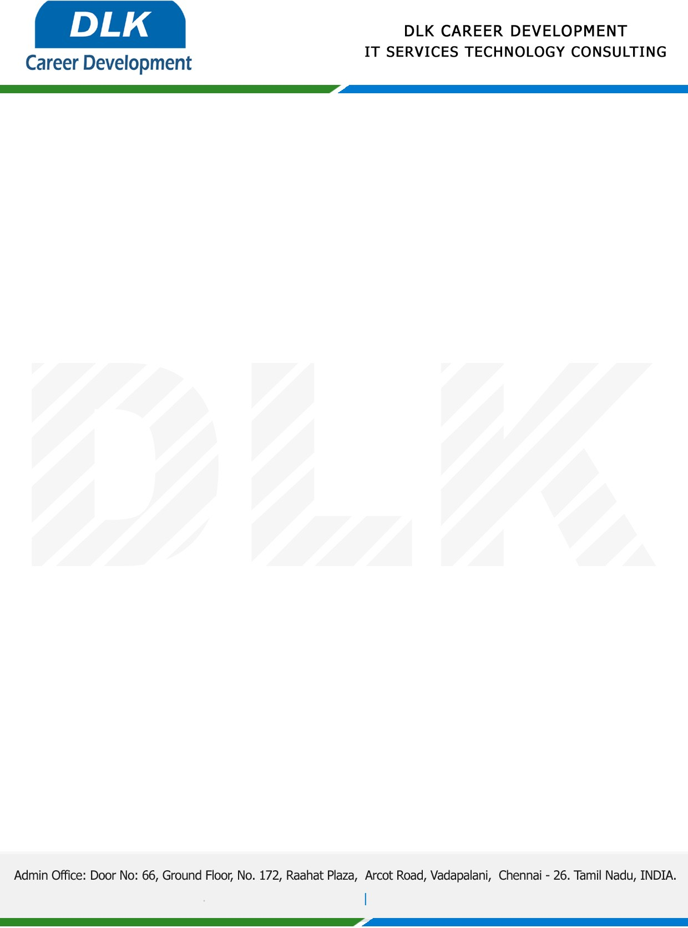

Date: 15/December/2022

**To**

Department of B.Tech (Information Technology) [,](https://www.cseindia.org/)

Head of Department,

Loyola Institute of Technology, Chennai -  600123.

**Sub: Letter of Internship Acceptance**

This is to certify that **MS PRIYADHARSHINI S(REG NO:** **210920205033)** final year student of has accepted the Internship Work duration from **07th March 2023 to 07th April 2023** under the domain **“Java”.** During the internship,all information and data collected from you should be kept confidential.

We appreciate your interest in **DLK CAREER DEVELOPMENT**

